1 run......

Downloading: 100%

464/464 [00:00<00:00, 6.60kB/s]

Downloading: 100%

270M/270M [00:06<00:00, 42.8MB/s]

training 1 epoch...

3.3876566886901855 seconds used......

1 training finished! average train loss: 1.2205985083299524

evaluating...

Confusion matrix, without normalization

[[ 30 1 10]

[ 77 4 14]

[358 47 309]]

Normalized confusion matrix

[[0.73170732 0.02439024 0.24390244]

[0.81052632 0.04210526 0.14736842]

[0.50140056 0.06582633 0.43277311]]

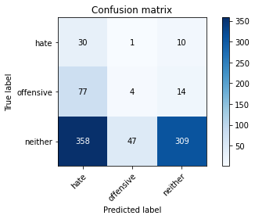

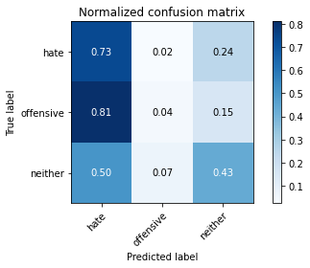

precision recall f1-score support

hate 0.06 0.73 0.12 41

offensive 0.08 0.04 0.05 95

neither 0.93 0.43 0.59 714

accuracy 0.40 850

macro avg 0.36 0.40 0.25 850

weighted avg 0.79 0.40 0.51 850

average eval_loss: 1.0724072220713594, accuracy: 0.40352941176470586

training 2 epoch...

2.5772061347961426 seconds used......

2 training finished! average train loss: 1.0506447308203752

evaluating...

Confusion matrix, without normalization

[[ 5 35 1]

[ 12 82 1]

[108 489 117]]

Normalized confusion matrix

[[0.12195122 0.85365854 0.02439024]

[0.12631579 0.86315789 0.01052632]

[0.1512605 0.68487395 0.16386555]]

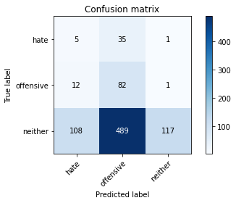

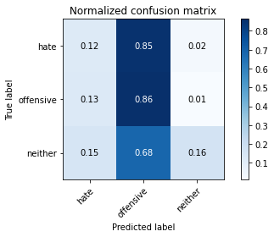

precision recall f1-score support

hate 0.04 0.12 0.06 41

offensive 0.14 0.86 0.23 95

neither 0.98 0.16 0.28 714

accuracy 0.24 850

macro avg 0.39 0.38 0.19 850

weighted avg 0.84 0.24 0.27 850

average eval_loss: 1.2371417852335198, accuracy: 0.24

training 3 epoch...

2.4862263202667236 seconds used......

3 training finished! average train loss: 0.9467313885688782

evaluating...

Confusion matrix, without normalization

[[ 21 10 10]

[ 40 13 42]

[194 128 392]]

Normalized confusion matrix

[[0.51219512 0.24390244 0.24390244]

[0.42105263 0.13684211 0.44210526]

[0.27170868 0.17927171 0.54901961]]

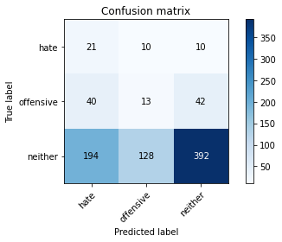

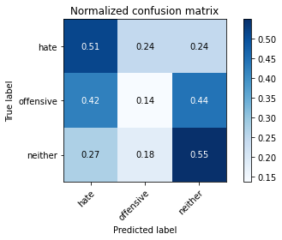

precision recall f1-score support

hate 0.08 0.51 0.14 41

offensive 0.09 0.14 0.11 95

neither 0.88 0.55 0.68 714

accuracy 0.50 850

macro avg 0.35 0.40 0.31 850

weighted avg 0.76 0.50 0.59 850

average eval_loss: 0.9866809872693794, accuracy: 0.5011764705882353

training 4 epoch...

2.478322982788086 seconds used......

4 training finished! average train loss: 0.8166161284727209

evaluating...

Confusion matrix, without normalization

[[ 32 4 5]

[ 58 16 21]

[332 113 269]]

Normalized confusion matrix

[[0.7804878 0.09756098 0.12195122]

[0.61052632 0.16842105 0.22105263]

[0.46498599 0.15826331 0.3767507 ]]

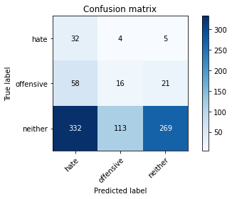

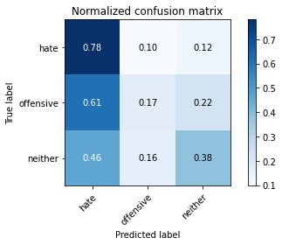

precision recall f1-score support

hate 0.08 0.78 0.14 41

offensive 0.12 0.17 0.14 95

neither 0.91 0.38 0.53 714

accuracy 0.37 850

macro avg 0.37 0.44 0.27 850

weighted avg 0.78 0.37 0.47 850

average eval_loss: 1.1956487526727277, accuracy: 0.3729411764705882

training 5 epoch...

2.481602907180786 seconds used......

5 training finished! average train loss: 0.6300337980775272

evaluating...

Confusion matrix, without normalization

[[ 27 10 4]

[ 38 44 13]

[268 238 208]]

Normalized confusion matrix

[[0.65853659 0.24390244 0.09756098]

[0.4 0.46315789 0.13684211]

[0.37535014 0.33333333 0.29131653]]

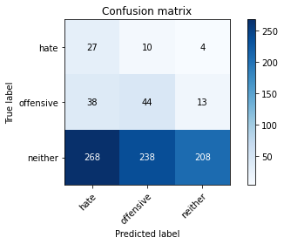

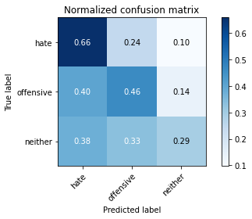

precision recall f1-score support

hate 0.08 0.66 0.14 41

offensive 0.15 0.46 0.23 95

neither 0.92 0.29 0.44 714

accuracy 0.33 850

macro avg 0.39 0.47 0.27 850

weighted avg 0.80 0.33 0.40 850

average eval_loss: 1.451055337523305, accuracy: 0.32823529411764707

training 6 epoch...

2.5495107173919678 seconds used......

6 training finished! average train loss: 0.45620661097414356

evaluating...

Confusion matrix, without normalization

[[ 14 23 4]

[ 7 73 15]

[107 301 306]]

Normalized confusion matrix

[[0.34146341 0.56097561 0.09756098]

[0.07368421 0.76842105 0.15789474]

[0.14985994 0.42156863 0.42857143]]

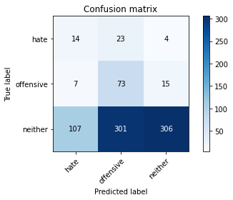

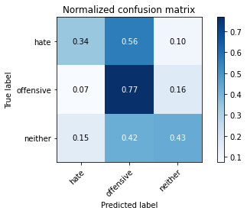

precision recall f1-score support

hate 0.11 0.34 0.17 41

offensive 0.18 0.77 0.30 95

neither 0.94 0.43 0.59 714

accuracy 0.46 850

macro avg 0.41 0.51 0.35 850

weighted avg 0.82 0.46 0.54 850

average eval_loss: 1.22239796488091, accuracy: 0.4623529411764706

training 7 epoch...

2.5136115550994873 seconds used......

7 training finished! average train loss: 0.26215049273827495

evaluating...

Confusion matrix, without normalization

[[ 17 11 13]

[ 15 36 44]

[101 188 425]]

Normalized confusion matrix

[[0.41463415 0.26829268 0.31707317]

[0.15789474 0.37894737 0.46315789]

[0.14145658 0.26330532 0.5952381 ]]

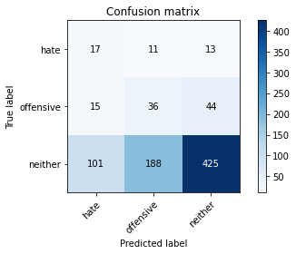

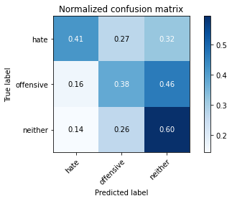

precision recall f1-score support

hate 0.13 0.41 0.20 41

offensive 0.15 0.38 0.22 95

neither 0.88 0.60 0.71 714

accuracy 0.56 850

macro avg 0.39 0.46 0.37 850

weighted avg 0.76 0.56 0.63 850

average eval_loss: 1.0203923040264569, accuracy: 0.5623529411764706

training 8 epoch...

2.539689540863037 seconds used......

8 training finished! average train loss: 0.14012955611242967

evaluating...

Confusion matrix, without normalization

[[ 15 13 13]

[ 9 43 43]

[ 84 230 400]]

Normalized confusion matrix

[[0.36585366 0.31707317 0.31707317]

[0.09473684 0.45263158 0.45263158]

[0.11764706 0.32212885 0.56022409]]

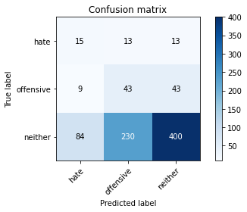

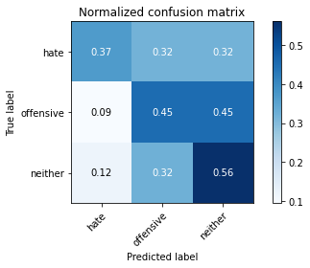

precision recall f1-score support

hate 0.14 0.37 0.20 41

offensive 0.15 0.45 0.23 95

neither 0.88 0.56 0.68 714

accuracy 0.54 850

macro avg 0.39 0.46 0.37 850

weighted avg 0.76 0.54 0.61 850

average eval_loss: 1.209004201601411, accuracy: 0.5388235294117647

training 9 epoch...

2.522684097290039 seconds used......

9 training finished! average train loss: 0.06400199979543686

evaluating...

Confusion matrix, without normalization

[[ 23 6 12]

[ 32 25 38]

[193 141 380]]

Normalized confusion matrix

[[0.56097561 0.14634146 0.29268293]

[0.33684211 0.26315789 0.4 ]

[0.27030812 0.19747899 0.53221289]]

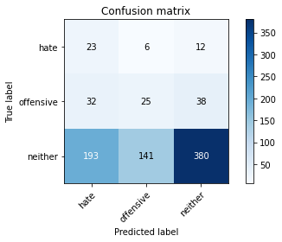

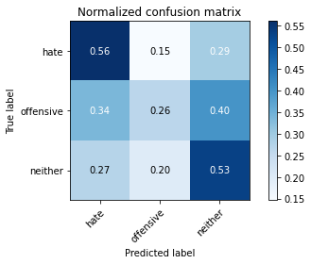

precision recall f1-score support

hate 0.09 0.56 0.16 41

offensive 0.15 0.26 0.19 95

neither 0.88 0.53 0.66 714

accuracy 0.50 850

macro avg 0.37 0.45 0.34 850

weighted avg 0.76 0.50 0.59 850

average eval_loss: 1.510513261090531, accuracy: 0.5035294117647059

training 10 epoch...

2.4787518978118896 seconds used......

10 training finished! average train loss: 0.03932137212113423

evaluating...

Confusion matrix, without normalization

[[ 23 7 11]

[ 27 28 40]

[163 177 374]]

Normalized confusion matrix

[[0.56097561 0.17073171 0.26829268]

[0.28421053 0.29473684 0.42105263]

[0.22829132 0.24789916 0.52380952]]

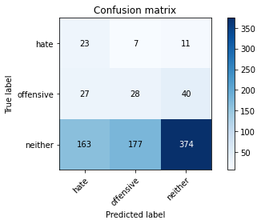

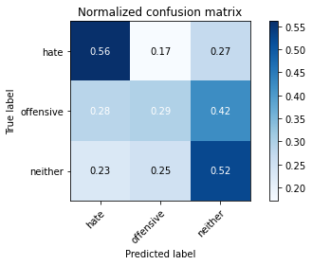

precision recall f1-score support

hate 0.11 0.56 0.18 41

offensive 0.13 0.29 0.18 95

neither 0.88 0.52 0.66 714

accuracy 0.50 850

macro avg 0.37 0.46 0.34 850

weighted avg 0.76 0.50 0.58 850

average eval_loss: 1.5837623919468633, accuracy: 0.5

2 run......

training 1 epoch...

2.5019290447235107 seconds used......

1 training finished! average train loss: 1.261225419885972

evaluating...

Confusion matrix, without normalization

[[ 39 1 1]

[ 93 1 1]

[539 36 139]]

Normalized confusion matrix

[[0.95121951 0.02439024 0.02439024]

[0.97894737 0.01052632 0.01052632]

[0.75490196 0.05042017 0.19467787]]

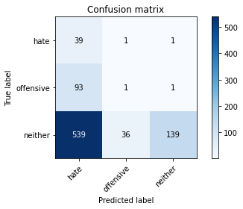

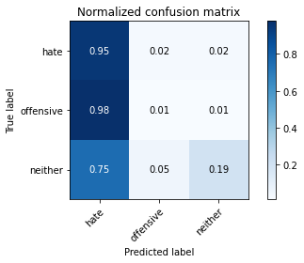

precision recall f1-score support

hate 0.06 0.95 0.11 41

offensive 0.03 0.01 0.02 95

neither 0.99 0.19 0.33 714

accuracy 0.21 850

macro avg 0.36 0.39 0.15 850

weighted avg 0.83 0.21 0.28 850

average eval_loss: 1.230731304301772, accuracy: 0.21058823529411766

training 2 epoch...

2.654223680496216 seconds used......

2 training finished! average train loss: 1.0563278618980856

evaluating...

Confusion matrix, without normalization

[[ 18 22 1]

[ 76 15 4]

[347 195 172]]

Normalized confusion matrix

[[0.43902439 0.53658537 0.02439024]

[0.8 0.15789474 0.04210526]

[0.4859944 0.27310924 0.24089636]]

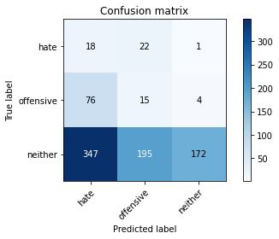

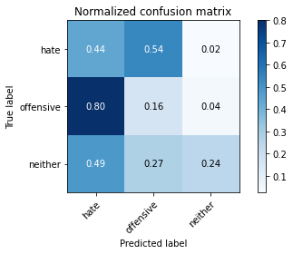

precision recall f1-score support

hate 0.04 0.44 0.07 41

offensive 0.06 0.16 0.09 95

neither 0.97 0.24 0.39 714

accuracy 0.24 850

macro avg 0.36 0.28 0.18 850

weighted avg 0.83 0.24 0.34 850

average eval_loss: 1.198928245278292, accuracy: 0.2411764705882353

training 3 epoch...

2.486689567565918 seconds used......

3 training finished! average train loss: 0.9760688262827256

evaluating...

Confusion matrix, without normalization

[[ 38 2 1]

[ 92 1 2]

[519 29 166]]

Normalized confusion matrix

[[0.92682927 0.04878049 0.02439024]

[0.96842105 0.01052632 0.02105263]

[0.72689076 0.04061625 0.232493 ]]

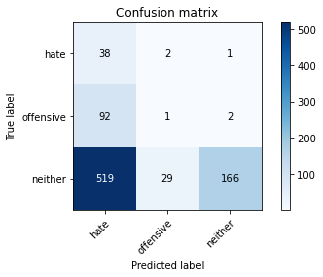

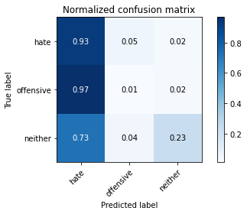

precision recall f1-score support

hate 0.06 0.93 0.11 41

offensive 0.03 0.01 0.02 95

neither 0.98 0.23 0.38 714

accuracy 0.24 850

macro avg 0.36 0.39 0.17 850

weighted avg 0.83 0.24 0.32 850

average eval_loss: 1.3134667914967204, accuracy: 0.2411764705882353

training 4 epoch...

2.4742820262908936 seconds used......

4 training finished! average train loss: 0.8829648319412681

evaluating...

Confusion matrix, without normalization

[[ 15 25 1]

[ 13 71 11]

[234 268 212]]

Normalized confusion matrix

[[0.36585366 0.6097561 0.02439024]

[0.13684211 0.74736842 0.11578947]

[0.32773109 0.37535014 0.29691877]]

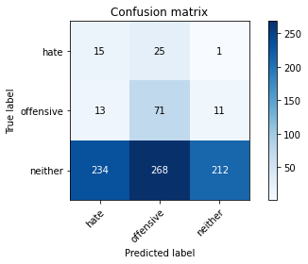

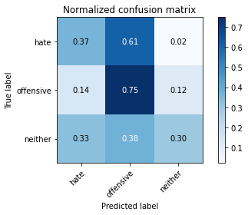

precision recall f1-score support

hate 0.06 0.37 0.10 41

offensive 0.20 0.75 0.31 95

neither 0.95 0.30 0.45 714

accuracy 0.35 850

macro avg 0.40 0.47 0.29 850

weighted avg 0.82 0.35 0.42 850

average eval_loss: 1.2078646532324857, accuracy: 0.35058823529411764

training 5 epoch...

2.474472761154175 seconds used......

5 training finished! average train loss: 0.7345943556112402

evaluating...

Confusion matrix, without normalization

[[ 19 20 2]

[ 16 34 45]

[215 203 296]]

Normalized confusion matrix

[[0.46341463 0.48780488 0.04878049]

[0.16842105 0.35789474 0.47368421]

[0.30112045 0.28431373 0.41456583]]

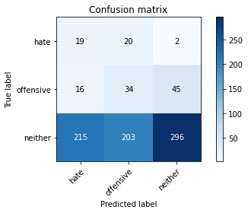

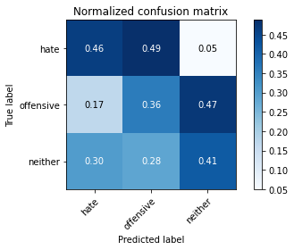

precision recall f1-score support

hate 0.08 0.46 0.13 41

offensive 0.13 0.36 0.19 95

neither 0.86 0.41 0.56 714

accuracy 0.41 850

macro avg 0.36 0.41 0.29 850

weighted avg 0.74 0.41 0.50 850

average eval_loss: 1.1409665935261304, accuracy: 0.41058823529411764

training 6 epoch...

2.477393865585327 seconds used......

6 training finished! average train loss: 0.5214329081423142

evaluating...

Confusion matrix, without normalization

[[ 26 11 4]

[ 22 20 53]

[237 102 375]]

Normalized confusion matrix

[[0.63414634 0.26829268 0.09756098]

[0.23157895 0.21052632 0.55789474]

[0.33193277 0.14285714 0.52521008]]

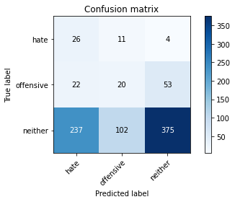

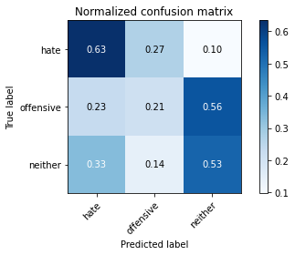

precision recall f1-score support

hate 0.09 0.63 0.16 41

offensive 0.15 0.21 0.18 95

neither 0.87 0.53 0.65 714

accuracy 0.50 850

macro avg 0.37 0.46 0.33 850

weighted avg 0.75 0.50 0.58 850

average eval_loss: 1.0690846699614858, accuracy: 0.49529411764705883

training 7 epoch...

2.512115478515625 seconds used......

7 training finished! average train loss: 0.34606075286865234

evaluating...

Confusion matrix, without normalization

[[ 30 8 3]

[ 40 13 42]

[336 102 276]]

Normalized confusion matrix

[[0.73170732 0.19512195 0.07317073]

[0.42105263 0.13684211 0.44210526]

[0.47058824 0.14285714 0.38655462]]

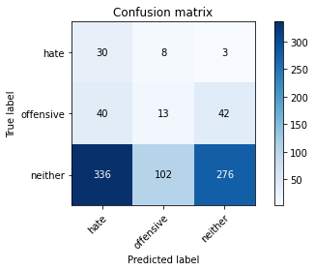

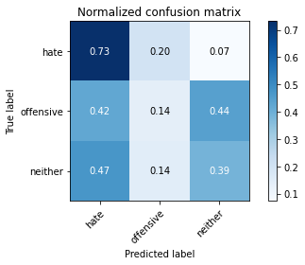

precision recall f1-score support

hate 0.07 0.73 0.13 41

offensive 0.11 0.14 0.12 95

neither 0.86 0.39 0.53 714

accuracy 0.38 850

macro avg 0.35 0.42 0.26 850

weighted avg 0.74 0.38 0.47 850

average eval_loss: 1.5794161031412524, accuracy: 0.37529411764705883

training 8 epoch...

2.484875202178955 seconds used......

8 training finished! average train loss: 0.17641260825535832

evaluating...

Confusion matrix, without normalization

[[ 17 16 8]

[ 12 32 51]

[153 168 393]]

Normalized confusion matrix

[[0.41463415 0.3902439 0.19512195]

[0.12631579 0.33684211 0.53684211]

[0.21428571 0.23529412 0.55042017]]

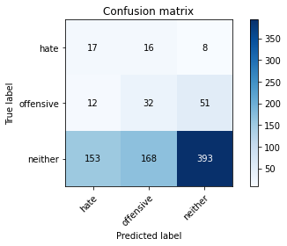

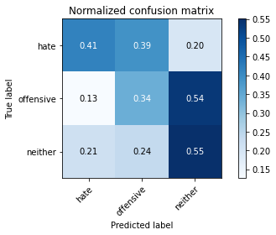

precision recall f1-score support

hate 0.09 0.41 0.15 41

offensive 0.15 0.34 0.21 95

neither 0.87 0.55 0.67 714

accuracy 0.52 850

macro avg 0.37 0.43 0.34 850

weighted avg 0.75 0.52 0.60 850

average eval_loss: 1.1936607645001522, accuracy: 0.52

training 9 epoch...

2.4997456073760986 seconds used......

9 training finished! average train loss: 0.08161917460315368

evaluating...

Confusion matrix, without normalization

[[ 18 17 6]

[ 13 33 49]

[146 190 378]]

Normalized confusion matrix

[[0.43902439 0.41463415 0.14634146]

[0.13684211 0.34736842 0.51578947]

[0.20448179 0.26610644 0.52941176]]

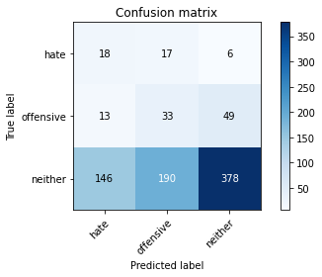

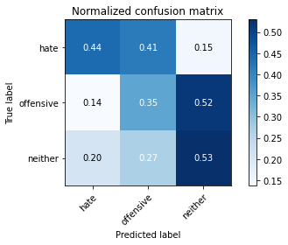

precision recall f1-score support

hate 0.10 0.44 0.17 41

offensive 0.14 0.35 0.20 95

neither 0.87 0.53 0.66 714

accuracy 0.50 850

macro avg 0.37 0.44 0.34 850

weighted avg 0.75 0.50 0.58 850

average eval_loss: 1.371456387604392, accuracy: 0.5047058823529412

training 10 epoch...

2.475576162338257 seconds used......

10 training finished! average train loss: 0.04090256605516462

evaluating...

Confusion matrix, without normalization

[[ 18 18 5]

[ 17 35 43]

[184 221 309]]

Normalized confusion matrix

[[0.43902439 0.43902439 0.12195122]

[0.17894737 0.36842105 0.45263158]

[0.25770308 0.30952381 0.43277311]]

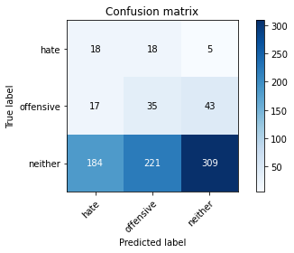

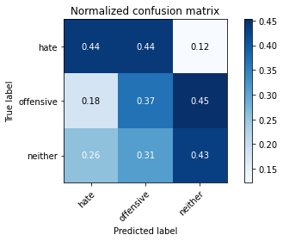

precision recall f1-score support

hate 0.08 0.44 0.14 41

offensive 0.13 0.37 0.19 95

neither 0.87 0.43 0.58 714

accuracy 0.43 850

macro avg 0.36 0.41 0.30 850

weighted avg 0.75 0.43 0.51 850

average eval_loss: 1.7510261889113936, accuracy: 0.4258823529411765

3 run......

training 1 epoch...

2.5011186599731445 seconds used......

1 training finished! average train loss: 1.2345142294378841

evaluating...

Confusion matrix, without normalization

[[ 30 9 2]

[ 81 5 9]

[443 88 183]]

Normalized confusion matrix

[[0.73170732 0.2195122 0.04878049]

[0.85263158 0.05263158 0.09473684]

[0.62044818 0.1232493 0.25630252]]

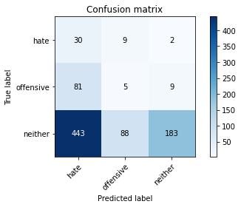

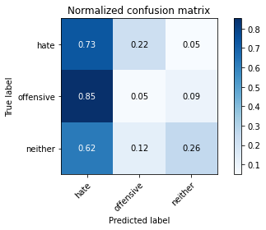

precision recall f1-score support

hate 0.05 0.73 0.10 41

offensive 0.05 0.05 0.05 95

neither 0.94 0.26 0.40 714

accuracy 0.26 850

macro avg 0.35 0.35 0.18 850

weighted avg 0.80 0.26 0.35 850

average eval_loss: 1.135281120621881, accuracy: 0.2564705882352941

training 2 epoch...

2.5511696338653564 seconds used......

2 training finished! average train loss: 1.075834365452037

evaluating...

Confusion matrix, without normalization

[[ 8 28 5]

[ 8 20 67]

[ 53 254 407]]

Normalized confusion matrix

[[0.19512195 0.68292683 0.12195122]

[0.08421053 0.21052632 0.70526316]

[0.07422969 0.3557423 0.57002801]]

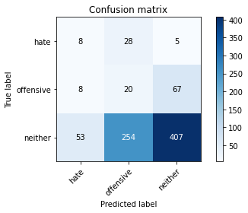

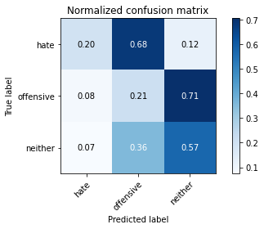

precision recall f1-score support

hate 0.12 0.20 0.15 41

offensive 0.07 0.21 0.10 95

neither 0.85 0.57 0.68 714

accuracy 0.51 850

macro avg 0.34 0.33 0.31 850

weighted avg 0.73 0.51 0.59 850

average eval_loss: 1.0187325851861821, accuracy: 0.5117647058823529

training 3 epoch...

2.478239059448242 seconds used......

3 training finished! average train loss: 0.9823106877944049

evaluating...

Confusion matrix, without normalization

[[ 12 28 1]

[ 44 49 2]

[200 368 146]]

Normalized confusion matrix

[[0.29268293 0.68292683 0.02439024]

[0.46315789 0.51578947 0.02105263]

[0.28011204 0.51540616 0.20448179]]

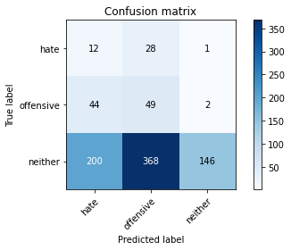

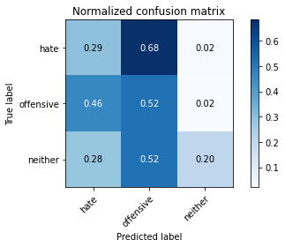

precision recall f1-score support

hate 0.05 0.29 0.08 41

offensive 0.11 0.52 0.18 95

neither 0.98 0.20 0.34 714

accuracy 0.24 850

macro avg 0.38 0.34 0.20 850

weighted avg 0.84 0.24 0.31 850

average eval_loss: 1.2671010854632356, accuracy: 0.24352941176470588

training 4 epoch...

2.4723923206329346 seconds used......

4 training finished! average train loss: 0.8683403520023122

evaluating...

Confusion matrix, without normalization

[[ 35 5 1]

[ 81 4 10]

[473 56 185]]

Normalized confusion matrix

[[0.85365854 0.12195122 0.02439024]

[0.85263158 0.04210526 0.10526316]

[0.66246499 0.07843137 0.25910364]]

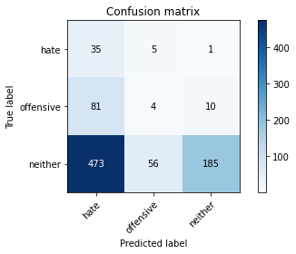

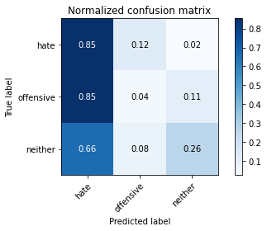

precision recall f1-score support

hate 0.06 0.85 0.11 41

offensive 0.06 0.04 0.05 95

neither 0.94 0.26 0.41 714

accuracy 0.26 850

macro avg 0.35 0.38 0.19 850

weighted avg 0.80 0.26 0.35 850

average eval_loss: 1.3237765805665838, accuracy: 0.2635294117647059

training 5 epoch...

2.4886114597320557 seconds used......

5 training finished! average train loss: 0.7454815226442674

evaluating...

Confusion matrix, without normalization

[[ 26 14 1]

[ 46 18 31]

[292 170 252]]

Normalized confusion matrix

[[0.63414634 0.34146341 0.02439024]

[0.48421053 0.18947368 0.32631579]

[0.40896359 0.23809524 0.35294118]]

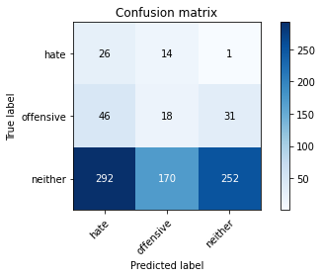

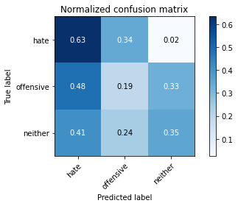

precision recall f1-score support

hate 0.07 0.63 0.13 41

offensive 0.09 0.19 0.12 95

neither 0.89 0.35 0.51 714

accuracy 0.35 850

macro avg 0.35 0.39 0.25 850

weighted avg 0.76 0.35 0.44 850

average eval_loss: 1.2261724229468856, accuracy: 0.34823529411764703

training 6 epoch...

2.508321762084961 seconds used......

6 training finished! average train loss: 0.5598320890875423

evaluating...

Confusion matrix, without normalization

[[ 27 11 3]

[ 28 14 53]

[255 135 324]]

Normalized confusion matrix

[[0.65853659 0.26829268 0.07317073]

[0.29473684 0.14736842 0.55789474]

[0.35714286 0.18907563 0.45378151]]

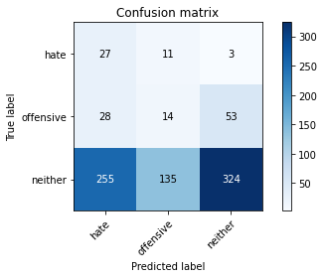

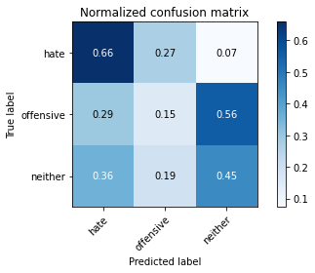

precision recall f1-score support

hate 0.09 0.66 0.15 41

offensive 0.09 0.15 0.11 95

neither 0.85 0.45 0.59 714

accuracy 0.43 850

macro avg 0.34 0.42 0.29 850

weighted avg 0.73 0.43 0.52 850

average eval_loss: 1.1930699507857478, accuracy: 0.4294117647058823

training 7 epoch...

2.5929248332977295 seconds used......

7 training finished! average train loss: 0.3665666501311695

evaluating...

Confusion matrix, without normalization

[[ 29 8 4]

[ 34 11 50]

[296 95 323]]

Normalized confusion matrix

[[0.70731707 0.19512195 0.09756098]

[0.35789474 0.11578947 0.52631579]

[0.41456583 0.13305322 0.45238095]]

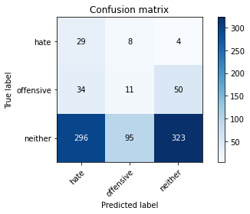

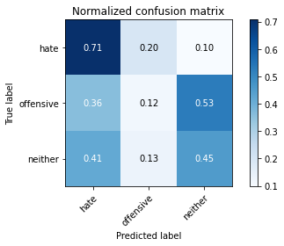

precision recall f1-score support

hate 0.08 0.71 0.15 41

offensive 0.10 0.12 0.11 95

neither 0.86 0.45 0.59 714

accuracy 0.43 850

macro avg 0.34 0.43 0.28 850

weighted avg 0.73 0.43 0.52 850

average eval_loss: 1.3431511188662328, accuracy: 0.42705882352941177

training 8 epoch...

2.4867160320281982 seconds used......

8 training finished! average train loss: 0.20186241847627304

evaluating...

Confusion matrix, without normalization

[[ 25 12 4]

[ 21 22 52]

[198 180 336]]

Normalized confusion matrix

[[0.6097561 0.29268293 0.09756098]

[0.22105263 0.23157895 0.54736842]

[0.27731092 0.25210084 0.47058824]]

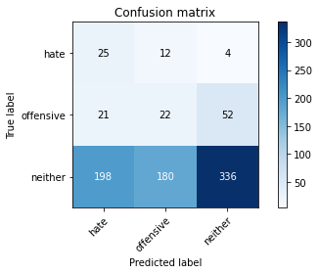

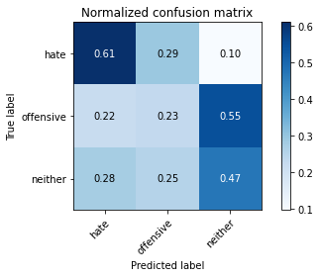

precision recall f1-score support

hate 0.10 0.61 0.18 41

offensive 0.10 0.23 0.14 95

neither 0.86 0.47 0.61 714

accuracy 0.45 850

macro avg 0.35 0.44 0.31 850

weighted avg 0.74 0.45 0.53 850

average eval_loss: 1.3981538986743882, accuracy: 0.4505882352941176

training 9 epoch...

2.518165349960327 seconds used......

9 training finished! average train loss: 0.08220506306080257

evaluating...

Confusion matrix, without normalization

[[ 25 13 3]

[ 18 33 44]

[186 217 311]]

Normalized confusion matrix

[[0.6097561 0.31707317 0.07317073]

[0.18947368 0.34736842 0.46315789]

[0.2605042 0.30392157 0.43557423]]

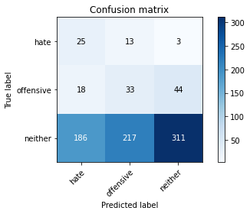

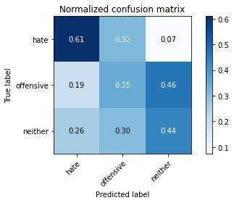

precision recall f1-score support

hate 0.11 0.61 0.19 41

offensive 0.13 0.35 0.18 95

neither 0.87 0.44 0.58 714

accuracy 0.43 850

macro avg 0.37 0.46 0.32 850

weighted avg 0.75 0.43 0.52 850

average eval_loss: 1.6229252279844395, accuracy: 0.43411764705882355

training 10 epoch...

2.48339581489563 seconds used......

10 training finished! average train loss: 0.03407908176236293

evaluating...

Confusion matrix, without normalization

[[ 26 12 3]

[ 24 26 45]

[191 203 320]]

Normalized confusion matrix

[[0.63414634 0.29268293 0.07317073]

[0.25263158 0.27368421 0.47368421]

[0.267507 0.28431373 0.44817927]]

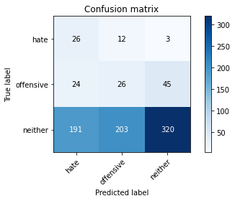

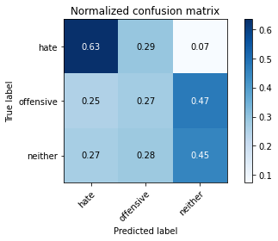

precision recall f1-score support

hate 0.11 0.63 0.18 41

offensive 0.11 0.27 0.15 95

neither 0.87 0.45 0.59 714

accuracy 0.44 850

macro avg 0.36 0.45 0.31 850

weighted avg 0.75 0.44 0.52 850

average eval_loss: 1.8092095841502034, accuracy: 0.4376470588235294

4 run......

training 1 epoch...

2.503450870513916 seconds used......

1 training finished! average train loss: 1.226723734070273

evaluating...

Confusion matrix, without normalization

[[ 36 3 2]

[ 90 4 1]

[584 67 63]]

Normalized confusion matrix

[[0.87804878 0.07317073 0.04878049]

[0.94736842 0.04210526 0.01052632]

[0.81792717 0.09383754 0.08823529]]

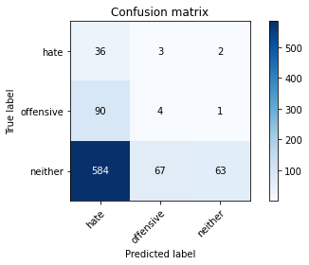

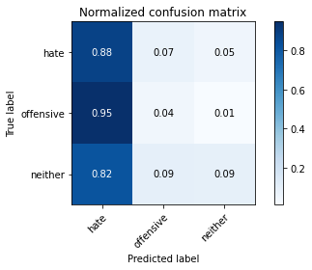

precision recall f1-score support

hate 0.05 0.88 0.10 41

offensive 0.05 0.04 0.05 95

neither 0.95 0.09 0.16 714

accuracy 0.12 850

macro avg 0.35 0.34 0.10 850

weighted avg 0.81 0.12 0.15 850

average eval_loss: 1.2635532312614972, accuracy: 0.12117647058823529

training 2 epoch...

2.5652272701263428 seconds used......

2 training finished! average train loss: 1.0443734386387993

evaluating...

Confusion matrix, without normalization

[[ 30 2 9]

[ 69 2 24]

[294 18 402]]

Normalized confusion matrix

[[0.73170732 0.04878049 0.2195122 ]

[0.72631579 0.02105263 0.25263158]

[0.41176471 0.02521008 0.56302521]]

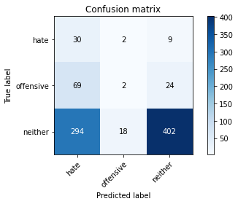

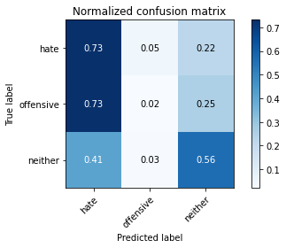

precision recall f1-score support

hate 0.08 0.73 0.14 41

offensive 0.09 0.02 0.03 95

neither 0.92 0.56 0.70 714

accuracy 0.51 850

macro avg 0.36 0.44 0.29 850

weighted avg 0.79 0.51 0.60 850

average eval_loss: 1.0004090202409168, accuracy: 0.5105882352941177

training 3 epoch...

2.476172924041748 seconds used......

3 training finished! average train loss: 0.954333038891063

evaluating...

Confusion matrix, without normalization

[[ 26 14 1]

[ 36 56 3]

[278 261 175]]

Normalized confusion matrix

[[0.63414634 0.34146341 0.02439024]

[0.37894737 0.58947368 0.03157895]

[0.38935574 0.36554622 0.24509804]]

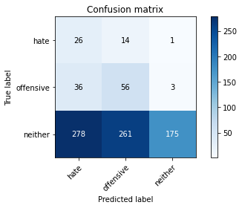

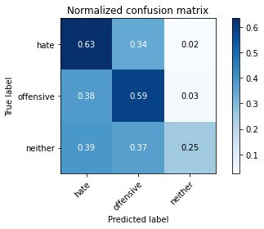

precision recall f1-score support

hate 0.08 0.63 0.14 41

offensive 0.17 0.59 0.26 95

neither 0.98 0.25 0.39 714

accuracy 0.30 850

macro avg 0.41 0.49 0.26 850

weighted avg 0.84 0.30 0.37 850

average eval_loss: 1.2390208992847176, accuracy: 0.3023529411764706

training 4 epoch...

2.489108085632324 seconds used......

4 training finished! average train loss: 0.8125893964486963

evaluating...

Confusion matrix, without normalization

[[ 34 4 3]

[ 60 9 26]

[414 68 232]]

Normalized confusion matrix

[[0.82926829 0.09756098 0.07317073]

[0.63157895 0.09473684 0.27368421]

[0.57983193 0.0952381 0.32492997]]

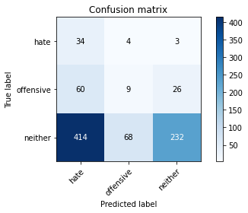

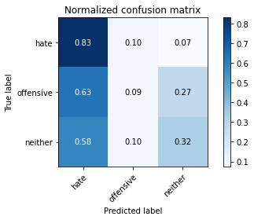

precision recall f1-score support

hate 0.07 0.83 0.12 41

offensive 0.11 0.09 0.10 95

neither 0.89 0.32 0.48 714

accuracy 0.32 850

macro avg 0.36 0.42 0.23 850

weighted avg 0.76 0.32 0.42 850

average eval_loss: 1.3019339047199072, accuracy: 0.3235294117647059

training 5 epoch...

2.479328155517578 seconds used......

5 training finished! average train loss: 0.7062724828720093

evaluating...

Confusion matrix, without normalization

[[ 30 5 6]

[ 34 11 50]

[270 81 363]]

Normalized confusion matrix

[[0.73170732 0.12195122 0.14634146]

[0.35789474 0.11578947 0.52631579]

[0.37815126 0.11344538 0.50840336]]

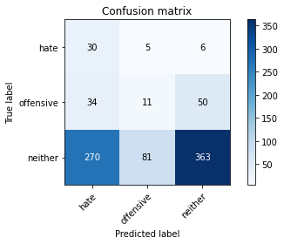

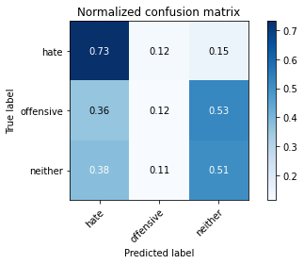

precision recall f1-score support

hate 0.09 0.73 0.16 41

offensive 0.11 0.12 0.11 95

neither 0.87 0.51 0.64 714

accuracy 0.48 850

macro avg 0.36 0.45 0.31 850

weighted avg 0.74 0.48 0.56 850

average eval_loss: 1.0792842878158702, accuracy: 0.4752941176470588

training 6 epoch...

2.4871959686279297 seconds used......

6 training finished! average train loss: 0.5069741396343007

evaluating...

Confusion matrix, without normalization

[[ 16 15 10]

[ 10 10 75]

[ 90 112 512]]

Normalized confusion matrix

[[0.3902439 0.36585366 0.24390244]

[0.10526316 0.10526316 0.78947368]

[0.12605042 0.15686275 0.71708683]]

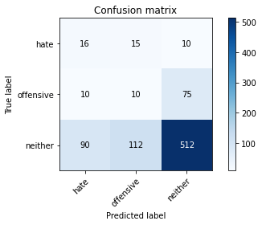

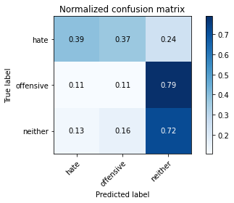

precision recall f1-score support

hate 0.14 0.39 0.20 41

offensive 0.07 0.11 0.09 95

neither 0.86 0.72 0.78 714

accuracy 0.63 850

macro avg 0.36 0.40 0.36 850

weighted avg 0.74 0.63 0.68 850

average eval_loss: 0.84069520650908, accuracy: 0.6329411764705882

training 7 epoch...

2.5781807899475098 seconds used......

7 training finished! average train loss: 0.30215488286579356

evaluating...

Confusion matrix, without normalization

[[ 22 15 4]

[ 24 43 28]

[180 242 292]]

Normalized confusion matrix

[[0.53658537 0.36585366 0.09756098]

[0.25263158 0.45263158 0.29473684]

[0.25210084 0.33893557 0.40896359]]

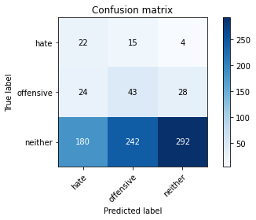

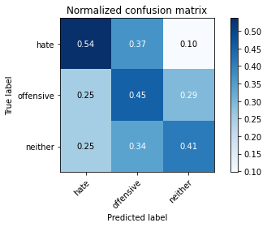

precision recall f1-score support

hate 0.10 0.54 0.16 41

offensive 0.14 0.45 0.22 95

neither 0.90 0.41 0.56 714

accuracy 0.42 850

macro avg 0.38 0.47 0.32 850

weighted avg 0.78 0.42 0.50 850

average eval_loss: 1.3679723789872125, accuracy: 0.42

training 8 epoch...

2.483839750289917 seconds used......

8 training finished! average train loss: 0.14322497914819157

evaluating...

Confusion matrix, without normalization

[[ 23 13 5]

[ 19 35 41]

[169 210 335]]

Normalized confusion matrix

[[0.56097561 0.31707317 0.12195122]

[0.2 0.36842105 0.43157895]

[0.23669468 0.29411765 0.46918768]]

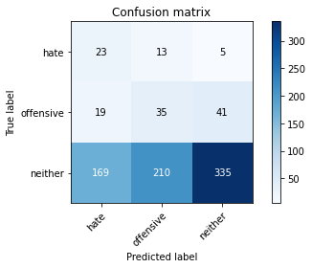

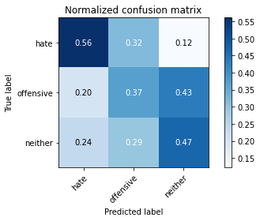

precision recall f1-score support

hate 0.11 0.56 0.18 41

offensive 0.14 0.37 0.20 95

neither 0.88 0.47 0.61 714

accuracy 0.46 850

macro avg 0.37 0.47 0.33 850

weighted avg 0.76 0.46 0.54 850

average eval_loss: 1.442802312848873, accuracy: 0.4623529411764706

training 9 epoch...

2.5281498432159424 seconds used......

9 training finished! average train loss: 0.07424269298858502

evaluating...

Confusion matrix, without normalization

[[ 20 11 10]

[ 18 16 61]

[149 138 427]]

Normalized confusion matrix

[[0.48780488 0.26829268 0.24390244]

[0.18947368 0.16842105 0.64210526]

[0.20868347 0.19327731 0.59803922]]

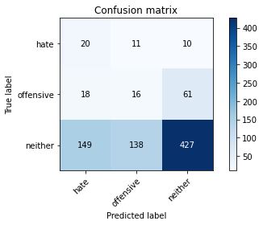

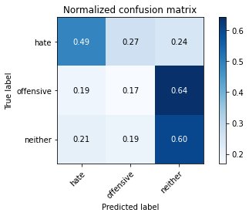

precision recall f1-score support

hate 0.11 0.49 0.18 41

offensive 0.10 0.17 0.12 95

neither 0.86 0.60 0.70 714

accuracy 0.54 850

macro avg 0.35 0.42 0.33 850

weighted avg 0.74 0.54 0.61 850

average eval_loss: 1.3041097442078036, accuracy: 0.5447058823529412

training 10 epoch...

2.4830398559570312 seconds used......

10 training finished! average train loss: 0.03334681087118738

evaluating...

Confusion matrix, without normalization

[[ 22 12 7]

[ 20 22 53]

[156 173 385]]

Normalized confusion matrix

[[0.53658537 0.29268293 0.17073171]

[0.21052632 0.23157895 0.55789474]

[0.21848739 0.24229692 0.53921569]]

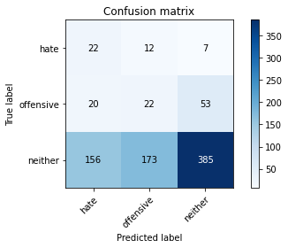

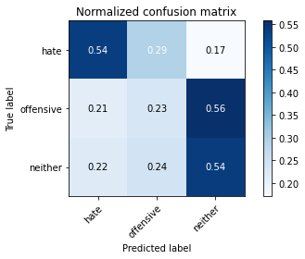

precision recall f1-score support

hate 0.11 0.54 0.18 41

offensive 0.11 0.23 0.15 95

neither 0.87 0.54 0.66 714

accuracy 0.50 850

macro avg 0.36 0.44 0.33 850

weighted avg 0.74 0.50 0.58 850

average eval_loss: 1.6143636170471476, accuracy: 0.5047058823529412

5 run......

training 1 epoch...

2.498568534851074 seconds used......

1 training finished! average train loss: 1.2277425317203297

evaluating...

Confusion matrix, without normalization

[[ 1 35 5]

[ 0 70 25]

[ 16 282 416]]

Normalized confusion matrix

[[0.02439024 0.85365854 0.12195122]

[0. 0.73684211 0.26315789]

[0.02240896 0.39495798 0.58263305]]

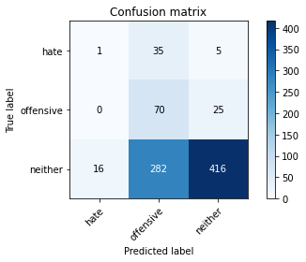

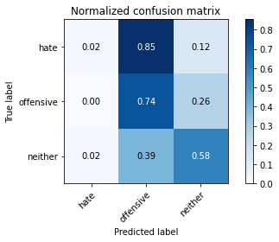

precision recall f1-score support

hate 0.06 0.02 0.03 41

offensive 0.18 0.74 0.29 95

neither 0.93 0.58 0.72 714

accuracy 0.57 850

macro avg 0.39 0.45 0.35 850

weighted avg 0.81 0.57 0.64 850

average eval_loss: 0.9992151274237522, accuracy: 0.5729411764705883

training 2 epoch...

2.5107243061065674 seconds used......

2 training finished! average train loss: 1.0756234421449549

evaluating...

Confusion matrix, without normalization

[[ 14 25 2]

[ 66 22 7]

[264 160 290]]

Normalized confusion matrix

[[0.34146341 0.6097561 0.04878049]

[0.69473684 0.23157895 0.07368421]

[0.3697479 0.22408964 0.40616246]]

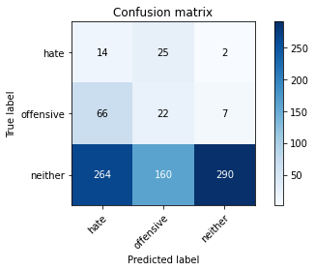

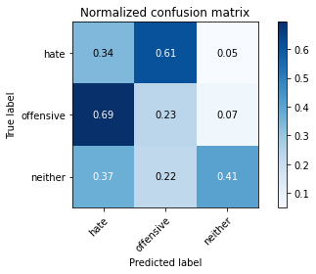

precision recall f1-score support

hate 0.04 0.34 0.07 41

offensive 0.11 0.23 0.15 95

neither 0.97 0.41 0.57 714

accuracy 0.38 850

macro avg 0.37 0.33 0.26 850

weighted avg 0.83 0.38 0.50 850

average eval_loss: 1.0874831870544788, accuracy: 0.3835294117647059

training 3 epoch...

2.478957176208496 seconds used......

3 training finished! average train loss: 0.9984359741210938

evaluating...

Confusion matrix, without normalization

[[ 26 5 10]

[ 70 3 22]

[296 22 396]]

Normalized confusion matrix

[[0.63414634 0.12195122 0.24390244]

[0.73684211 0.03157895 0.23157895]

[0.41456583 0.03081232 0.55462185]]

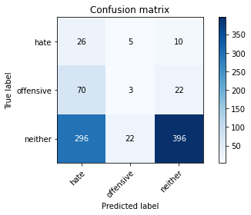

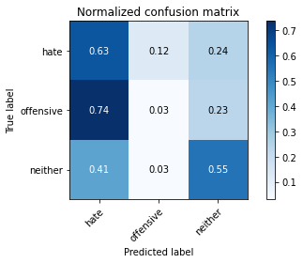

precision recall f1-score support

hate 0.07 0.63 0.12 41

offensive 0.10 0.03 0.05 95

neither 0.93 0.55 0.69 714

accuracy 0.50 850

macro avg 0.36 0.41 0.29 850

weighted avg 0.79 0.50 0.59 850

average eval_loss: 0.9652361772781195, accuracy: 0.5

training 4 epoch...

2.47774600982666 seconds used......

4 training finished! average train loss: 0.932485422667335

evaluating...

Confusion matrix, without normalization

[[ 7 24 10]

[ 2 41 52]

[ 61 177 476]]

Normalized confusion matrix

[[0.17073171 0.58536585 0.24390244]

[0.02105263 0.43157895 0.54736842]

[0.08543417 0.24789916 0.66666667]]

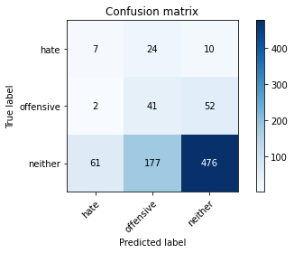

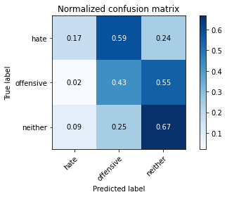

precision recall f1-score support

hate 0.10 0.17 0.13 41

offensive 0.17 0.43 0.24 95

neither 0.88 0.67 0.76 714

accuracy 0.62 850

macro avg 0.38 0.42 0.38 850

weighted avg 0.77 0.62 0.67 850

average eval_loss: 0.8801294932531756, accuracy: 0.6164705882352941

training 5 epoch...

2.480531930923462 seconds used......

5 training finished! average train loss: 0.7586607722675099

evaluating...

Confusion matrix, without normalization

[[ 9 23 9]

[ 10 61 24]

[138 212 364]]

Normalized confusion matrix

[[0.2195122 0.56097561 0.2195122 ]

[0.10526316 0.64210526 0.25263158]

[0.19327731 0.29691877 0.50980392]]

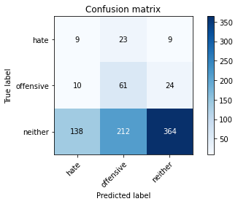

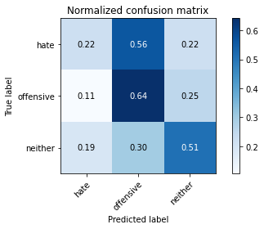

precision recall f1-score support

hate 0.06 0.22 0.09 41

offensive 0.21 0.64 0.31 95

neither 0.92 0.51 0.66 714

accuracy 0.51 850

macro avg 0.39 0.46 0.35 850

weighted avg 0.80 0.51 0.59 850

average eval_loss: 1.0364075944174167, accuracy: 0.5105882352941177

training 6 epoch...

2.4858503341674805 seconds used......

6 training finished! average train loss: 0.5593830084099489

evaluating...

Confusion matrix, without normalization

[[ 20 8 13]

[ 32 12 51]

[225 71 418]]

Normalized confusion matrix

[[0.48780488 0.19512195 0.31707317]

[0.33684211 0.12631579 0.53684211]

[0.31512605 0.09943978 0.58543417]]

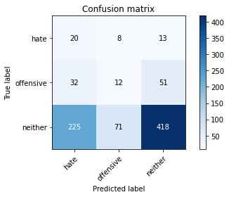

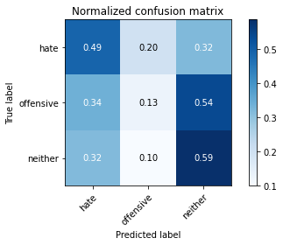

precision recall f1-score support

hate 0.07 0.49 0.13 41

offensive 0.13 0.13 0.13 95

neither 0.87 0.59 0.70 714

accuracy 0.53 850

macro avg 0.36 0.40 0.32 850

weighted avg 0.75 0.53 0.61 850

average eval_loss: 1.0117560240418413, accuracy: 0.5294117647058824

training 7 epoch...

2.530162811279297 seconds used......

7 training finished! average train loss: 0.3417285435339984

evaluating...

Confusion matrix, without normalization

[[ 16 14 11]

[ 9 64 22]

[138 192 384]]

Normalized confusion matrix

[[0.3902439 0.34146341 0.26829268]

[0.09473684 0.67368421 0.23157895]

[0.19327731 0.26890756 0.53781513]]

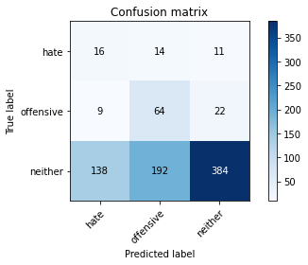

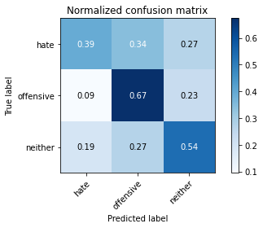

precision recall f1-score support

hate 0.10 0.39 0.16 41

offensive 0.24 0.67 0.35 95

neither 0.92 0.54 0.68 714

accuracy 0.55 850

macro avg 0.42 0.53 0.40 850

weighted avg 0.80 0.55 0.62 850

average eval_loss: 1.1101638920778452, accuracy: 0.5458823529411765

training 8 epoch...

2.4874589443206787 seconds used......

8 training finished! average train loss: 0.17441649910281687

evaluating...

Confusion matrix, without normalization

[[ 19 10 12]

[ 16 38 41]

[181 125 408]]

Normalized confusion matrix

[[0.46341463 0.24390244 0.29268293]

[0.16842105 0.4 0.43157895]

[0.2535014 0.17507003 0.57142857]]

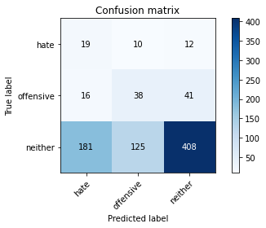

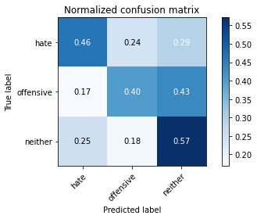

precision recall f1-score support

hate 0.09 0.46 0.15 41

offensive 0.22 0.40 0.28 95

neither 0.89 0.57 0.69 714

accuracy 0.55 850

macro avg 0.40 0.48 0.38 850

weighted avg 0.77 0.55 0.62 850

average eval_loss: 1.2148392581662466, accuracy: 0.5470588235294118

training 9 epoch...

2.5151753425598145 seconds used......

9 training finished! average train loss: 0.08157673631520833

evaluating...

Confusion matrix, without normalization

[[ 17 13 11]

[ 10 34 51]

[132 150 432]]

Normalized confusion matrix

[[0.41463415 0.31707317 0.26829268]

[0.10526316 0.35789474 0.53684211]

[0.18487395 0.21008403 0.60504202]]

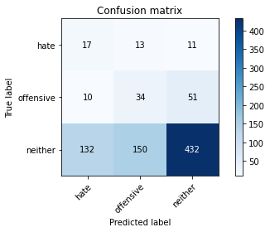

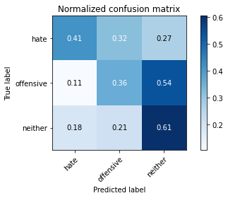

precision recall f1-score support

hate 0.11 0.41 0.17 41

offensive 0.17 0.36 0.23 95

neither 0.87 0.61 0.72 714

accuracy 0.57 850

macro avg 0.38 0.46 0.37 850

weighted avg 0.76 0.57 0.64 850

average eval_loss: 1.252804375491863, accuracy: 0.5682352941176471

training 10 epoch...

2.484586715698242 seconds used......

10 training finished! average train loss: 0.0338373005609302

evaluating...

Confusion matrix, without normalization

[[ 16 14 11]

[ 18 34 43]

[154 160 400]]

Normalized confusion matrix

[[0.3902439 0.34146341 0.26829268]

[0.18947368 0.35789474 0.45263158]

[0.21568627 0.22408964 0.56022409]]

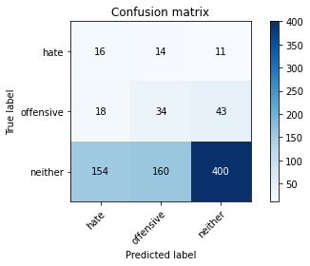

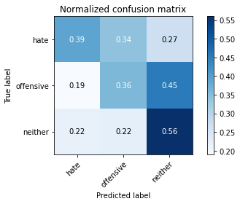

precision recall f1-score support

hate 0.09 0.39 0.14 41

offensive 0.16 0.36 0.22 95

neither 0.88 0.56 0.68 714

accuracy 0.53 850

macro avg 0.38 0.44 0.35 850

weighted avg 0.76 0.53 0.61 850

average eval_loss: 1.5109450503490691, accuracy: 0.5294117647058824